8.21

I had an issue with this one and the tester. It kept throwing errors and I could not quite see the issue.

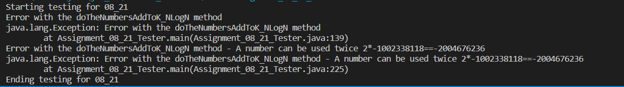

8.27

With this one I used the sorting method and then just compared the index to the previous index.

8.33

With this one I also used the sort method and then just compared the two outcomes.

